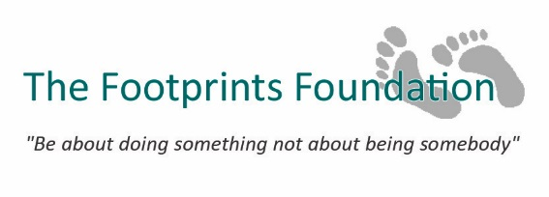

Privacy Policy

We take the protection of your personal data very seriously. This is why it is important for us to identify how we process your personal data and the controls that you have over this.
This privacy policy sets out what personal data we will collect from you, how we collect it and our reasons for doing so.

By accessing and using our website you agree to the terms of this policy. Any amendments to this policy will be identified on this page. By continuing to use our website after these amendments have been made you agree to the terms of the revised policy.

1. DataController

The data controller of the personal data that we process for you is “The Footprints Foundation” at 37 St Georges Road, Cheltenham GL50 3NU

2. What personal data we collect from you and how do we collect it?

Volunteers

When you request to be a volunteer on one of our international projects we will collect the following personal data from you:

Personal details, including your name, email address; medical information via questionnaire: passport details
Contact details, including your address and your phone number

Patrons Programme sponsors

When you agree to become a Patron or Friend of our Patrons Programme we will collect the following personal data from you:

Personal details, including your work, name, email address

3. Why do we collect your personal data?

We will only use personal data from you in the following ways:

To contact you with information and updates on the volunteer project
To ensure you are fit and able to take part in the volunteer project
To ensure we have the correct details when booking flights for volunteers
To keep you informed of progress of the Patrons Programme

4. The General Data Protection Regulation – our obligations to you

Under the General Data Protection Regulation (GDPR), we have a legal obligation to protect any personal data that we process. To this end we will only use your personal data for the purposes we have described above.

As part of our commitment to protecting your personal data, we will:
- keep your personal data confidential at all times,
- hold your personal data only for the duration of your volunteer project

5. Sharing your personal data

We will never share your personal data with third parties

6. Your rights

You have the right to:
- request a copy of the personal data that we hold for you,
- let us know if there are any errors in the personal data that we hold for you,
- request us to delete any of the personal data that we hold for you,

Please email us at info@thefootprintsfoundation.co.uk (link sends e-mail) to let us know.

If you are not happy about the way in which we have processed your personal data, please email us at info@thefootprintsfoundation.co.uk (link sends e-mail) to let us know and we will try to rectify this to your satisfaction.

Alternatively, if you wish to lodge a complaint with the Information Commissioner’s Office (ICO), you should call the ICO helpline on 0303 123 1113 or report your concern on the ICO’s website at https://ico.org.uk/concerns/ (link is external).

